Geralyn Fellows
Speech-Language Pathologist
Smithtown Central School District
Elementary Grades

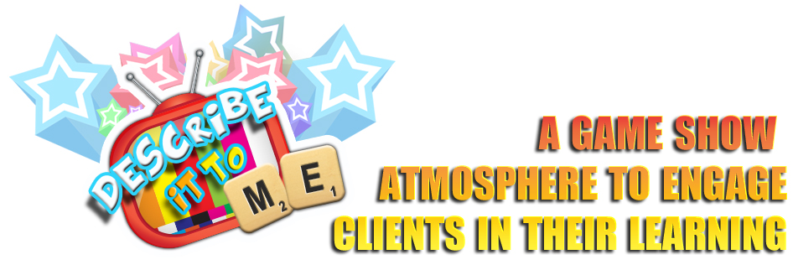

Application: Describe it to ME
Smarty Ears: http://smartyearsapps.com/service/describe/

This application begins at the level of categorization, and then builds to a deeper understanding of the vocabulary. Students learn semantic knowledge. The vocabulary focuses on everyday items. The app can also be used to facilitate semantic knowledge in adults. The application is a game format. A finger swipe determines if the activity is receptive or expressive. By tapping a button, the application will focus on category, function, parts, location and visuals. The teacher/therapist/parent controls the category. Vocabulary can be selected or deselected. The application also promotes turn taking skills, because the student that has control of the spinner is the student’s turn. The application keeps data on the student’s progression. (160 pictures) The pictures are viewed on a television as if the student is watching a game show.

The receptive language is a multiple-choice format. (Field of 4 choices) The questions can focus on one item and go through category, location, parts, function, visuals (What can I see?) and extra (What else do I know about the object?), or the lesson can focus on just one of the question items. The question is read to the student, but the choices are not. If the student is unable to read the choices, the facilitator needs to read the selections.

The expressive language portion is the picture with the question read to the student. Under the question is the grading (correct, almost and incorrect), which is marked by the facilitator.
Homework Handouts:
The application also has homework sheets that can be printed. They focus on the six areas of questions. Some of the worksheets are multiple choice, matching word to picture, circle all the words that describe the object, or write 6 words that describe the object given a picture.

Common Core Standards

There are 3 Tiers of Vocabulary Words
This application focuses on :

The Three Vocabulary Tiers
Tier 1: Common, Known Words
Examples: big, small, house, table, family
In other words, Tier I words are basic, everyday words found frequently in conversation and are part of most children’s vocabulary.

CCSS.ELA-LITERACY.L.1.5.A
Sort words into categories (e.g., colors, clothing) to gain a sense of the concepts the categories represent.
CCSS.ELA-LITERACY.L.1.5.B
Define words by category and by one or more key attributes (e.g., a duck is a bird that swims; a tiger is a large cat with stripes).
CCSS.ELA-LITERACY.L.1.5.C
Identify real-life connections between words and their use (e.g., note places at home that are cozy).

Additional Comment
When the students have mastered the ability to define a word, the strategy learned in this application can be applied to unfamiliar vocabulary in the context of the text. Wh-questions would be presented by the facilitator to expressively state the meaning of a word. (ie. Where would you find this?, Who would use this)

