Name: Chano Itwaru
District: Brentwood Union Free School District
Grade: K-12
Subject: English as a Second Language (Beginner, Intermediate and Advanced English Language Learners)
Name of App: EASY English Part 1
CCLS Standards Addressed for K-12
ELA: Key Ideas and Details
With prompting and support, retell familiar stories, including key details
Craft and Structure: Identify the front cover, back cover and title page of a book
Reading: Foundational Skills: Demonstrate understanding of the organization and basic features of print.
Speaking and Listening: Presentation of Knowledge and Ideas
Describe familiar people, places, things, and events with prompting and support, provide additional detail.
Language: Conventions of Standard English. Demonstrate command of the conventions of Standard English capitalization punctuation, and spelling when writing. Vocabulary acquisition and use; demonstrate the command of the conventions of Standard English capitalization, punctuation, and spelling when writing. Use words and phrases acquired through conversations, reading and being read to, and responding to texts, including using adjectives and adverbs to describe
Writing: Text types and Purposes. Use a variety of digital tools to produce and publish writing including in collaboration with peers.
Website: http://www.easyesl.net 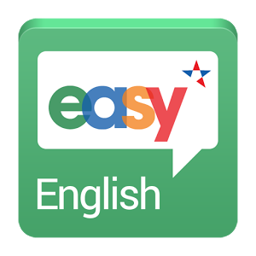

Description of Apps: EASY English Part 1 (cost $9.95 for full access)
Beginner ESL students learn English with videos which are appropriate for all ages and ability levels. There are over 90 videos and perfect for self-study and English practice. Students can follow the actors by watching, listening, recording and speaking in English. The videos are interactive and very easy to follow. Teachers can also print the scripts, the vocabulary words, practice quizzes, and tests. The videos are motivating and the scenarios are real life stories that motivate students to listen, speak, read, and write in English.

The videos come with lesson plans, scripts, vocabulary lists and practice worksheets and tests and are aligned to U.S. standards K-12. There is a scope and sequence from the Basics (learning the alphabet to months of the year), Interactions, Feelings, School, Home and Family, and Telling Time.

