Name: Chano Itwaru
District: Brentwood Union Free School District
Grade: Beginner Intermediate, Advanced and Proficient English Language Learners
Subject: English as a Second Language
Name of App: HMH Readers by Houghton Mifflin Harcourt Education (available on iOs, Windows and Android) . The app that I reviewed are free but I purchased one at $2.99 to implement with students).
CCLS Standards Addressed:
Key Ideas and Details
- Read closely to determine what the text says explicitly and to make logical inferences from it; cite specific textual evidence when writing or speaking to support conclusions drawn from the text.
- Determine central ideas or themes of a text and analyze their development; summarize the key supporting details and ideas.
- Analyze how and why individuals, events, and ideas develop and interact over the course of a text.
Craft and Structure
- Interpret words and phrases as they are used in a text, including determining technical, connotative, and figurative meanings, and analyze how specific word choices shape meaning or tone.
- Analyze the structure of texts, including how specific sentences, paragraphs, and larger portions of the text (e.g., a section, chapter, scene, or stanza) relate to each other and the whole.
- Assess how point of view or purpose shapes the content and style of a text.
Integration of Knowledge and Ideas
- Integrate and evaluate content presented in diverse formats and media, including visually and quantitatively, as well as in words.*
- Delineate and evaluate the argument and specific claims in a text, including the validity of the reasoning as well as the relevance and sufficiency of the evidence.
- Analyze how two or more texts address similar themes or topics in order to build knowledge or to compare the approaches the authors take.
Range of Reading and Level of Text Complexity
- Read and comprehend complex literary and informational texts independently and proficiently.
Responding to Literature
- Respond to literature by employing knowledge of literary language, textual features, and forms to read and comprehend, reflect upon, and interpret literary texts from a variety of genres and a wide spectrum of American and world cultures.

Website: http://www.hmhco.com/ 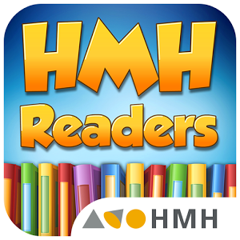

Description of HMH Readers:

HMH Readers feature interesting non-fiction and fiction selections designed for young readers to reinforce reading skills, to promote academic vocabulary acquisition, and to improve reading fluency and comprehension. Teachers can use these free online, interactive readers, levels K-6, as supplemental to a unit and to differentiate instruction, based on student’s varied learning needs. However, the leveled-readers are appropriate for 7th and 8th English language learners because of students’ ability levels. Students can record themselves reading, using the read aloud feature, or turning on the highlighter so each word is highlighted when reading. At the end of all the stories target skill questions are stated where students provide constructed responses and apply story elements knowledge and critical thinking skills.
These leveled-readers also make a connection across curriculum and address with CCSS for grades 3-8 in social studies and science.

