Name: Geralyn Fellows
School: Smithtown Central School District
Speech and Language K-5
Subject: ELA

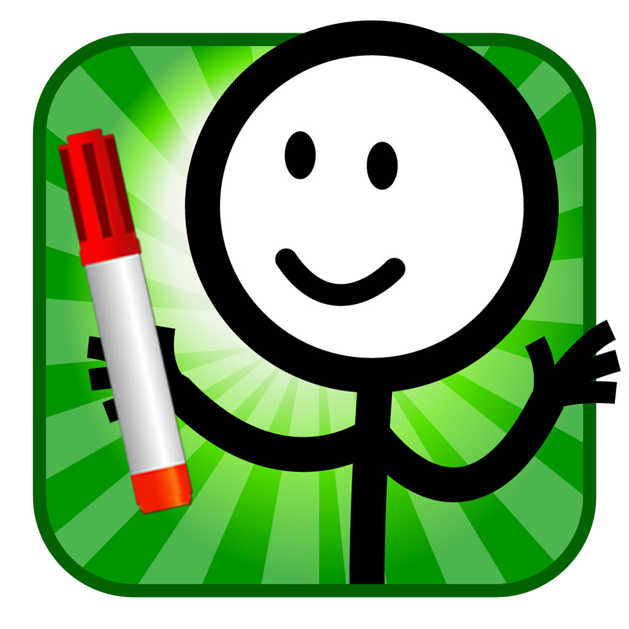 4.99 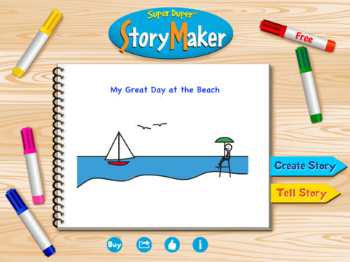

Application: Story Maker Application (Super Duper)

http://www.superduperinc.com/products/view.aspx?stid=661#buyNow

Common Core Standards

Kindergarten
Reading Literature
RL.K.2 Key Ideas and Details
2.With prompting an support, retell familiar stories, including key details
RL.K.3 Key Ideas and Details
3. With prompting and support, identify characters, setting, and major events in a story
Reading: informational Text
RI.K.5 Craft and Structure
5. Identify the front cover, back cover and title page of a book
Reading: Foundational Skills
RF.K.1 Print Concepts
1. Demonstrate understanding of the organization and basic features of print. (Follow words left to right, spaces of words in text, recognize letters.

Speaking and Listening
SL.K.4 Presentation of Knowledge and Ideas
4. Describe familiar people, places, things, and events with prompting and support, provide additional detail
SL.K.5 Presentation of Knowledge and Ideas
5. Add drawings or other visual displays to descriptions as desired to re

Language
L.K.2 Conventions of Standard English
2. Demonstrate command of the conventions of Standard English capitalization punctuation, and spelling when writing.

First Grade
Reading and Literature
RL.1.K Integration of Knowledge and Ideas
7. Use illustrations and details in a story to describe its characters, setting or events
Reading Informational Text
RI.1.7 Integration of Knowledge and Ideas
7. Use the illustrations and details in a text to describe its key ideas
Writing
W.1.3 Text types and Purposes
3. Write narratives in which they recount two or more appropriately sequenced events, include some details regarding what happened, use temporal words to signal event order and provide some sense of closure
W.1.6 Production and Distribution of Writing
6. With guidance and support from adults, use a variety of digital tools to produce and publish writing including in collaboration with peers.
W.1.6 Production and Distribution of Writing
6. With guidance and support form adults, use a variety of digital tools to produce and publish writing including in collaboration with peers.
Speaking and Listening
SL.1.4 Presentation of Knowledge and Ideas
4. Describe people, places things and events with relevant details, expressing ideas and feelings clearly
SL.1.6 Presentation of Knowledge and Ideas
6. Produce complete sentences when appropriate to task and situation

Second Grade
Reading Literature
RL.2.5 Craft and Structure
5. Describe the overall structure of a story, including describing how the beginning introduces the story and the ending concludes the action.
RI.2.4 Reading Informational Text
4. Determine the meaning of words and phrases in a text relevant to a grade 2 topic or subject
RI.2.10 Range of Reading and Level of Text Complexity

10. By the end of the year, read and comprehend informational texts, including history/social studies science and technical texts in the grades 2-3 text complexity band proficiently with scaffolding as needed at the high end of the range.
Speaking and Listening
SL.2.4 Presentation of Knowledge and Ideas
4. Tell a story or recount an experience with appropriate facts and relevant descriptive details speaking audibly in coherent sentences
5. Create audio recordings of stories or poems, add drawings, or other visual displays to stories or recounts of experiences when appropriate to clarify ideas, thoughts, and feelings.
Language
S.2.6 Vocabulary acquisition and Use
2. Demonstrate the command of the conventions of Standard English capitalization, punctuation, and spelling when writing
6. Use words and phrases acquired through conversations, reading and being read to, and responding to texts, including using adjectives and adverbs to describe

Story Maker- Super Duper
This application focuses on the following:
- Tell stories
- Retell stories
- Improve reading skills
- Increase Vocabulary
- Practice grammar
- Practice Sentence Building

Parts of the Story Maker Application:
- Create Stories-make stories and edit

- Tell Stories-Read and talk about your story

Feature: Record Voice and tell the story
- Speech Intelligibility
- Prosody
- Meta-linguistic
- Student can listen to syntax
- Expand utterances

Topic: Student creates a title for their story
Main Idea: Student formulates a complete sentence to define the main idea, written expression/ verbal expression
Details: Student uses grammatically complete sentences /written expression
Sequence: Student uses language or written expression to create a story sequence

Illustrations
- Provided pictures to search
- Students can draw the illustration
- Students can take a picture
- Students can search the internet for a picture
Vocabulary:
- The student uses/brainstorms vocabulary related to the topic
- The student uses the vocabulary in a complete sentence
- The educator can create a word bank related to the topic

Genres:
- The student can create a fiction story
- The student can create a nonfiction story
- Poetry

Encoding and Decoding
- Practice reading
- Practice spelling

The students can use Story Maker to make a postcard, make a card, comic book, develop thematic vocabulary, informational text

Incorporation:
This application can align with many of the standards. I have focused on the English Standards. It can be used for creative writing, informational text, poetry, creating a dialogue in a comic strip, using parts of speech, such as adjectives. The student uses descriptive vocabulary when writing their story. It is also useful for enabling the students to present their work to their peers. The student can focus on speech production, and the use of social skills. The student can focus on

writing mechanics and syntax. I have used the application to create a story in the small group setting. The students have generated facts for
non-fiction text, and have told a story about a theme by sharing their ideas. We have brainstormed adjectives and adverbs, and used as many as we could in the story. The student’s also enjoy using the illustrations
provided and drawing their own characters. They can add to images to be creative. The students have also written a postcard, and selected an image from the internet. (ie. the rainforest, the desert, and had to write a note about their trip).
The story can also include the literary elements such as onomatopoeia and create sounds for their story, or alliteration and use particular sound sequences in the story.
To work on phonological awareness, the students can focus on a particular phoneme or rhyme.
The possibilities for use of this application are vast. It is a creative means for the students to use written expression or verbal expression to communicate their ideas. Given directives, the student would focus on the standard indicated by the educator.

